A Step-by-Step Demo: Engaging in the projects using Git

Step 1: Install Git
- Download and install Git from the official website, https://git-scm.com/downloads . Follow the instructions for your operating system. i.e Windows, macOS or Linux.
- Remember to choose the default options unless you have specific preferences.
- Verify your installation using this prompt:
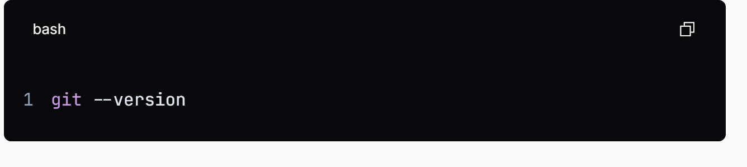
Step 2: Set Up Git
- Configure Your Git Identity by setting up your username and your email
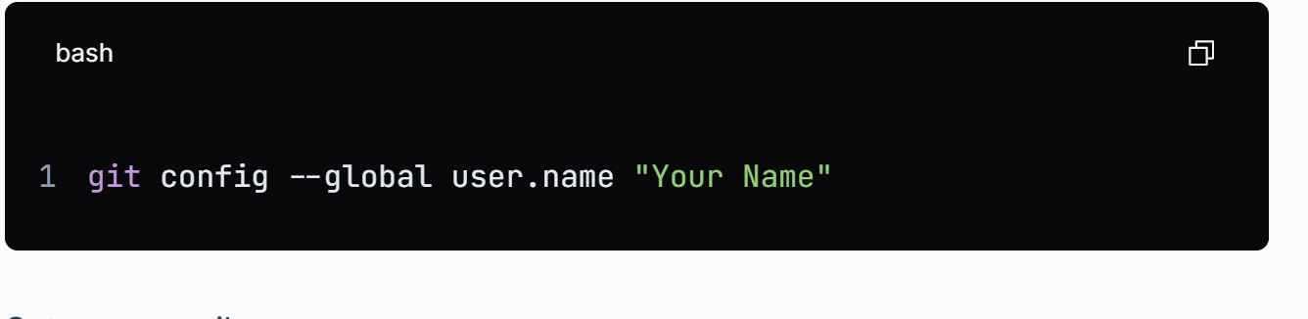
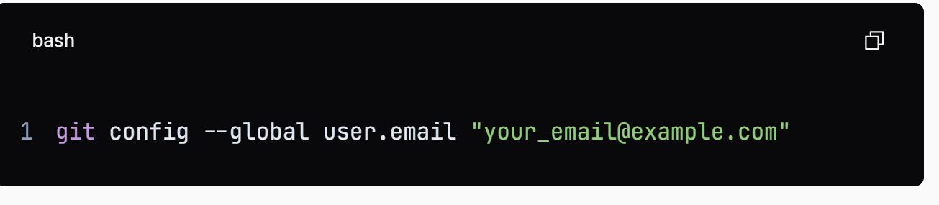
- Check Configuration by running:
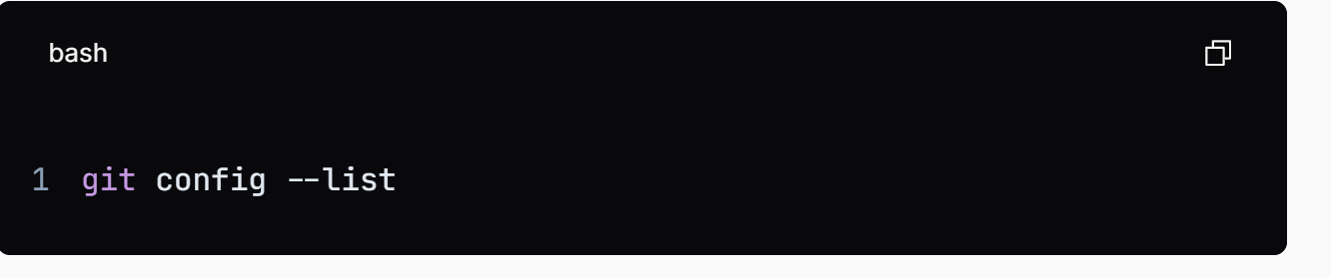
Step 3: Clone the Repository Locally
- Clone the Repository to create a local copy of the repo: (An Illustration)
- Copy the repository URL (HTTPS or SSH).
- Open your terminal and navigate to the directory where you want to store the project.
- Run the following command (replace <repository-url> with the copied URL):
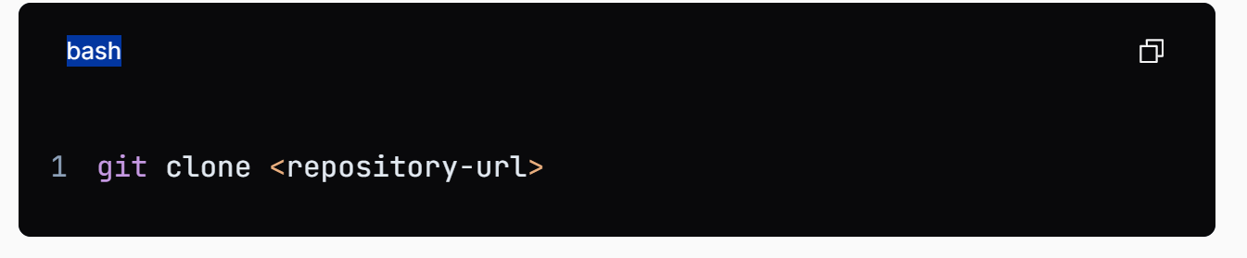
Step 4: Add Project Files
- Navigate to the Repository Directory
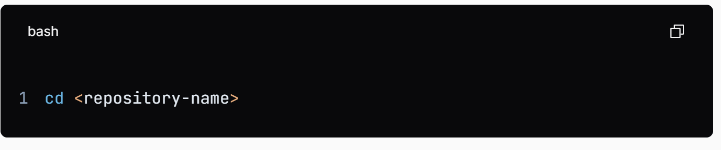

Step 5: Open the Repository in VS Code
- Open the Cloned Repository:
  - In VS Code, go to File > Open Folder... and select the folder of the cloned repository.
Step 6: Add or Modify Project Files
- Edit Files:
  - Use the VS Code editor to add new files or modify existing ones. You can create new files by right-clicking in the Explorer pane and selecting New File.
Step 7: Stage, Commit, and Push Changes
- Stage Your Changes:
  - In the terminal, after making changes, stage the files you want to commit:
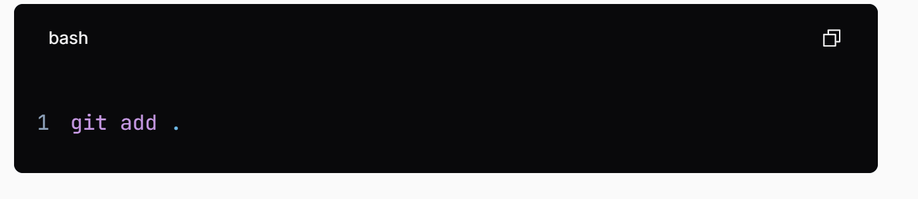
- Commit Your Changes:
- Commit the staged changes with a descriptive message:
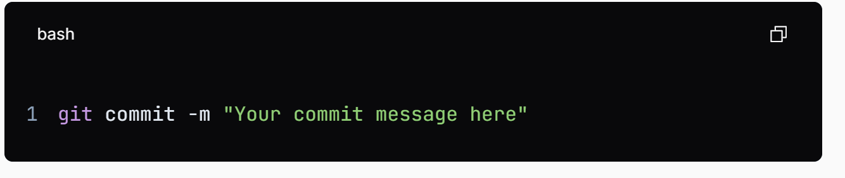
- Or you can also commit using the Source Control view by entering your commit message in the input box at the top and clicking the checkmark icon.

- Push Changes to GitHub:
- Push your changes to the remote repository
- Replace main with the name of the branch you are working on.
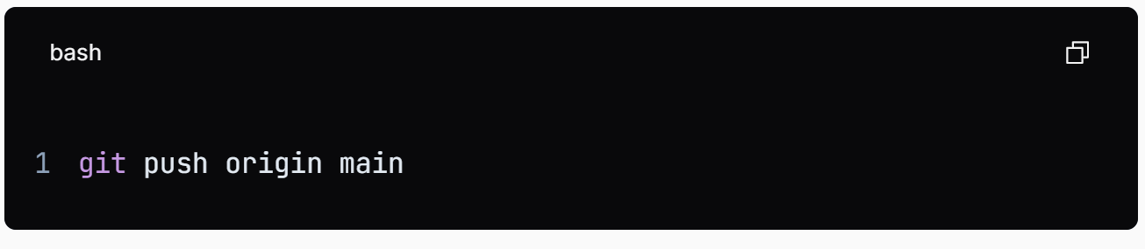

Step 9: Create a Pull Request (Optional)
- Go to the Repository on GitHub:
  - Click on the "Pull requests" tab.
  - Click on "New pull request."
- Select Your Branch:
  - Choose the branch you pushed your changes to and compare it with the main branch.
- Create the Pull Request:
- After selecting the branches to compare, you will see a summary of the changes.
- Add a title and description for the pull request to explain what changes you made and why.
- Click the "Create pull request" button to submit your pull request.

